**INTERNATIONAL WOMEN DAY:**



**INTRODUCTION:**

Today, we gather to commemorate a day of utmost significance - International Women's Day. This annual observance, held on March 8th, serves as a poignant reminder of the remarkable contributions and enduring struggles of women worldwide.

International Women's Day traces its roots back to the early 20th century, a time of burgeoning social movements and fervent calls for change. It emerged from the labour movements in North America and Europe, where women courageously marched for better working conditions, fair wages, and the right to vote.

Since then, International Women's Day has evolved into a global celebration of women's achievements across all spheres of society - from politics to science, business to the arts. It stands as a testament to the indomitable spirit and resilience of women who have shattered glass ceilings, defied stereotypes, and championed the cause of gender equality.

**History of International Women's Day:**

- Originated from labour movements in the early 20th century.

- Officially recognized by the United Nations in 1977.

- A day to commemorate women's rights and promote gender equality.

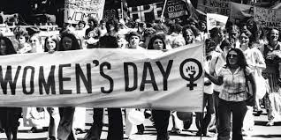

**Significance of International Women's Day:**

- Highlights the progress made towards gender equality.

- Raises awareness about ongoing challenges faced by women.

- Empowers women and advocates for their rights globally.

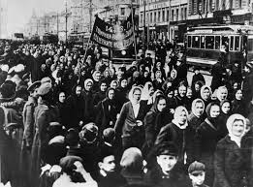

**Themes of International Women's Day:**

- Each year, a different theme reflects current global issues.

- Recent themes include gender parity, women's leadership, and #EachforEqual.

- Themes serve as a call to action for progress and change.

**Challenges Faced by Women:**

- Gender pay gap and unequal access to economic opportunities.

- Violence against women and girls persists worldwide.

- Limited representation in leadership and decision-making roles.

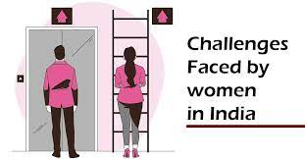

**Importance of Women's Empowerment:**

- Empowering women is essential for sustainable development.

- Women's participation enhances social and economic progress.

- Gender equality benefits everyone in society.

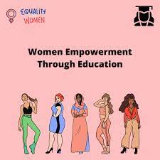

**Ways to Participate:**

- Attend events, workshops, and seminars promoting gender equality.

- Support women-owned businesses and initiatives.

- Use social media to amplify women's voices and share stories of empowerment.

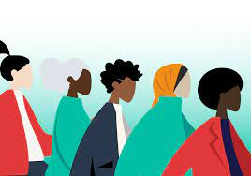

**Celebrating Women's Achievements:**

- Recognize and celebrate the accomplishments of women in all fields.

- Highlight inspiring stories of resilience and leadership.

- Acknowledge the contributions of women from diverse backgrounds.

**Renewed Commitment to Gender Equality:**

- Pledge to continue advocating for women's rights and equality.

- Support policies and initiatives that promote gender equity.

- Work together to create a more inclusive and equitable world for all.

**Conclusion**

- International Women's Day is a time to celebrate progress and inspire change.

- Let us continue to empower women, challenge stereotypes, and build a more equitable future.